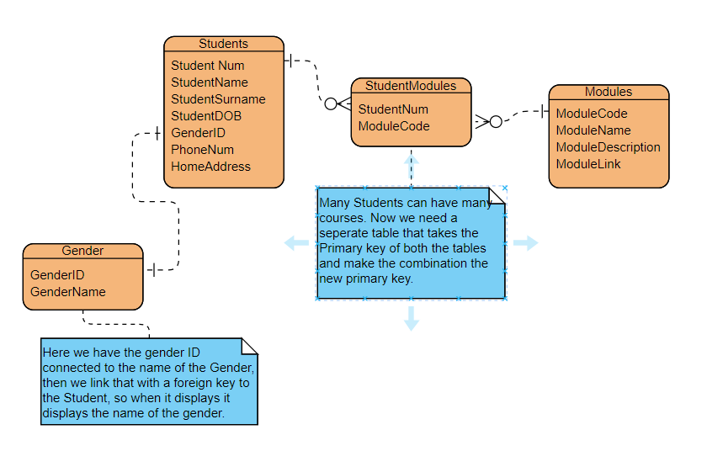

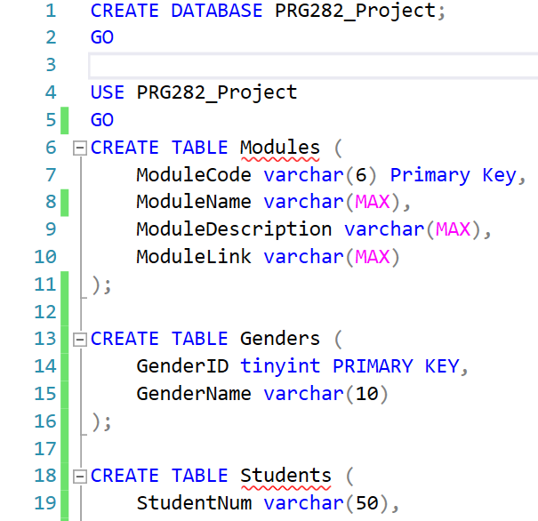

This is the format we will use with the text boxes. We will use the “|” to separate the usernames from the passwords. We will use character handling to get the username and password.